West Hull Ladies
RRC

December Newsletter

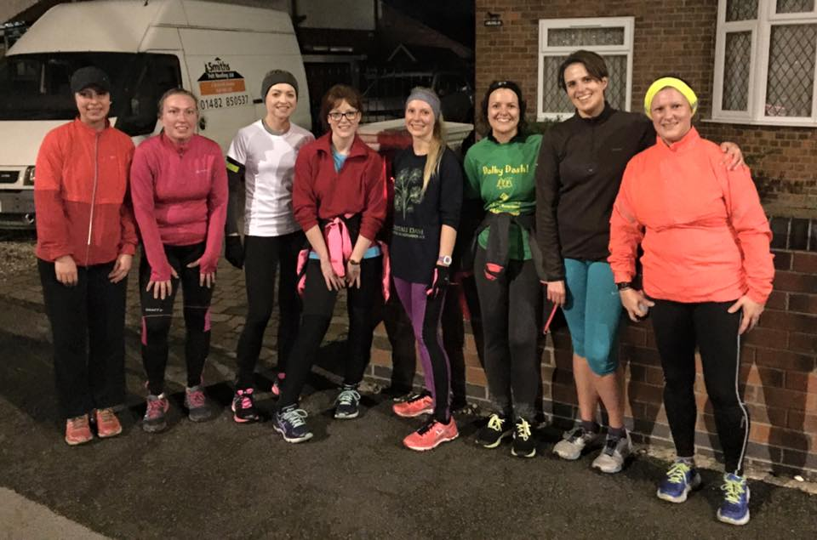

West Hull Ladies
WEST HULL LADIES RRC COMMITTEE MEETING

Minutes Committee Meeting 30th November 2015
Present - Jill, Zoe, Jan, Maria, Sandra, Amanda, Andrea, Linda, Liz

- Apologies received from Annette, Karen and Anna
- Minutes from previous meeting agreed as accurate record
- Matters arising - Maria updated the Committee in relation to funding. We would have to research where we could obtain funding from and then submit a bid. Action Liz to research initially through CVS. In relation to hoodies Sandra said she was still awaiting a reply from PB teamwear. Agreed we should purchase plain hoodies and have the logo embroidered on as we had done earlier on in the year. Action Sandra to purchase hoodies.
- In relation to YVAA Multi Terrain Grand Prix Series it was agreed that it was not feasible for us as a Club to host the series due to not having sufficiently trained officials.
- Funding matters as above (3) Liz to further.
- Discussed whether as a Club we would be able to staff the West Park Water Stn for Hull Marathon 2016. Agreed that it was very probable we could do this with help from members and their family/friends. Also that we were happy to help with goody bag packing. Action Amanda to send email to organisers informing them of this. (Sent 30.11.15)
- Agreed that the annual Award Ceremony would be held on the 11th March 2016 and that the Back Room be contacted to see if available. Action - Jan to contact Back Room Cottingham.
- 0-5k update. Further publicity required. Members to put up posters where they could. To be further updated on 21st December after Advent Run.
- Jill stated that it would be a good idea for the newsletter to have an article discussing underwear for running. Agreed this would be beneficial and Jill to ask members for any comments and for them to be collated for a newsletter article. Action Jill to email members.

Meet a Member : Sarah

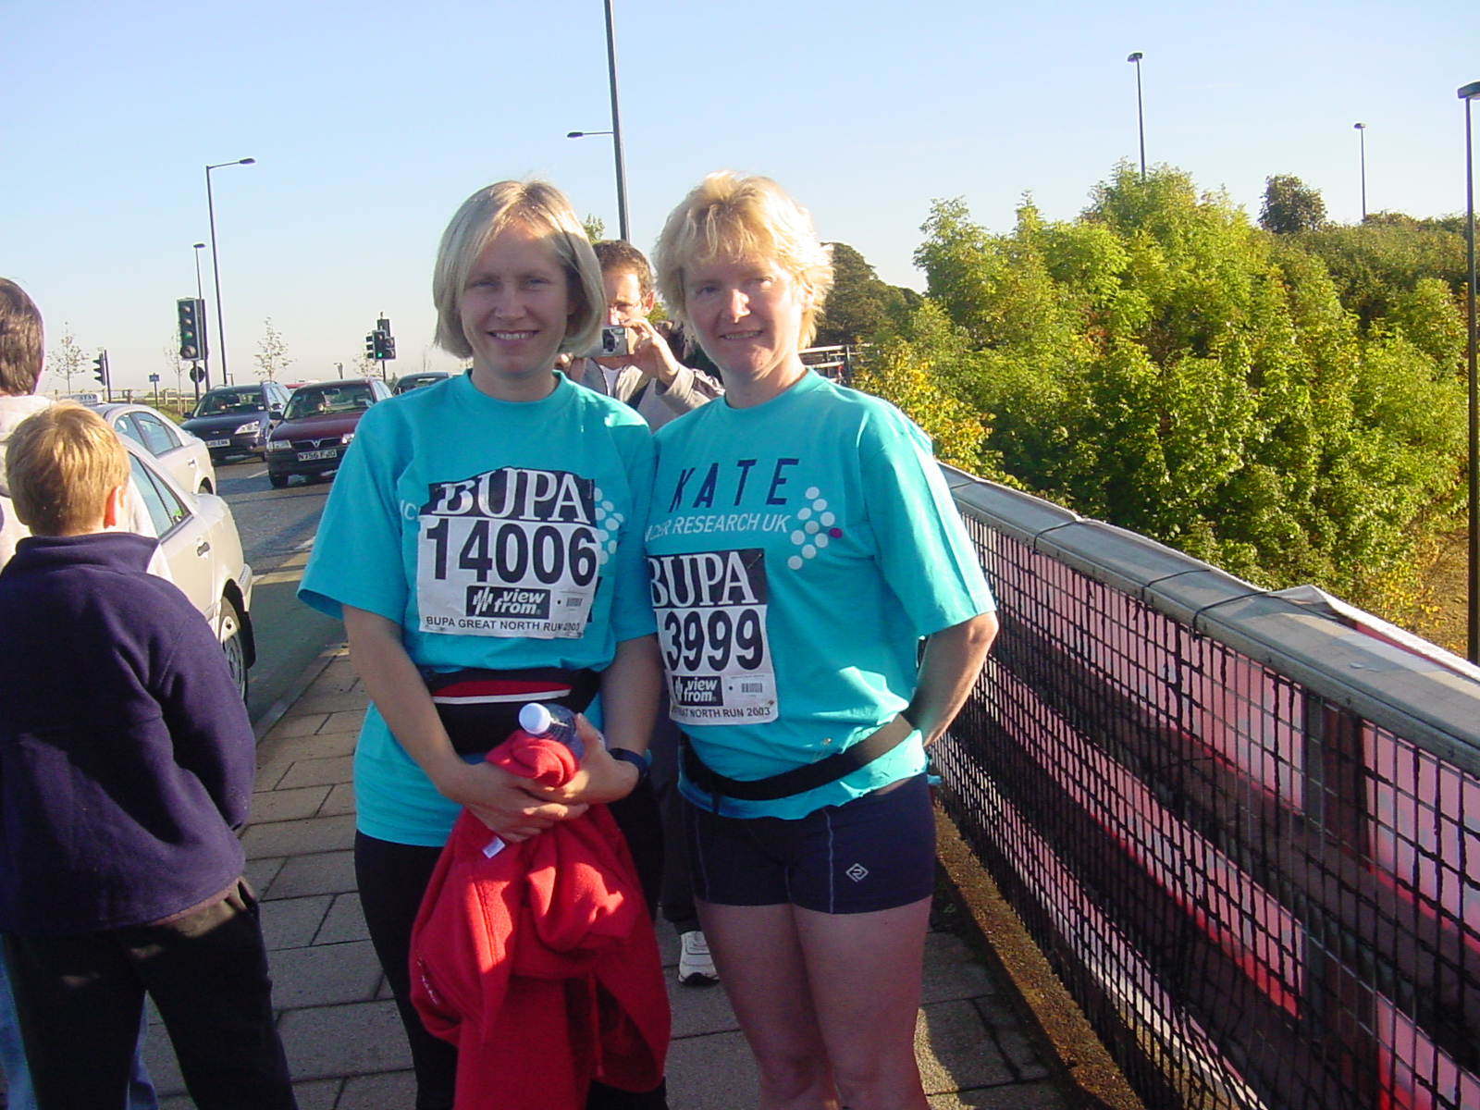

Name Sarah Wilson

Age 52

Member of WHL since – October 2014

What do you do when you’re not running? – ( work/hobbies/family)
Work – I’m Headteacher of a primary school
Spend time with my husband and family
Walk – I love bagging peaks in the Lake District, but don’t get there often enough!
Church activities, reading, watching a good drama on the TV.
How long have you been running? - 13 years
Why did you start running?
I was never sporty at school. If it was a rounder's match then I was the last to get picked, hockey I’d run away from the ball....but I’ve always loved walking and for a long time felt the pull of running. Finally on 9th March 2002, at the ripe old age of 38, the day after a work night out when we’d been discussing our lack of exercise, I got up early and went for a walk/run and there it began. Three mornings a week I’d leave the house at 6.00 and run for half an hour before work. Sometimes I’d go at the weekend as well. I soon persuaded my friend Kate to join me, and together we ran 5ks, 10ks and the Great North Run on 3 occasions, but mostly, we just plodded along in the early morning, having a natter. We didn’t get any faster, but were glad to have squeezed a bit of exercise in to our busy days.
We ran together as Kate contemplated becoming a foster carer, and then in the early days of her being ‘Mum’ to 2 lovely girls. We ran as I screamed and cried and wondered how I was going to survive following my husband’s cancer diagnosis and eventual death. And we ran along the canal in Marple on the morning of my wedding day in 2011.
Following my marriage to the lovely Pete, I moved from Marple to South Cave, My commute became longer, the working day more demanding, and running started to disappear. Apart from Parkruns, it became really difficult to squeeze runs in. I kept trying, and kept failing. I started to think that my running days were over. Then Liz (stepdaughter Liz Draper) joined West Hull Ladies and eventually persuaded me that if I joined too I wouldn’t be the slowest! Joining has meant I’ve met some wonderful and inspiring women, it’s helped me get back into a regular routine of running, and it’s enabled me to achieve things I never imagined, like the Golden Fleece, PBs for 10k and half marathon. I’d always thought that running clubs would be just for elite runners, but have been really welcomed into WHL and love its inclusivity.
For me, running is therapy. It’s all about a healthy lifestyle, physically and mentally. I know I’ll never be fast, I’ll never win prizes, but I can achieve things I never thought possible. I’m looking forward to seeing what else is in store with WHL.

Favourite distance – 10k, although I do love my Parkruns!

Favourite bit of running kit – My Garmin

Any injuries? – I’m currently struggling with pain and numbness in my leg, resulting from a back problem, which the wonderful Jamie is sorting out.
Running goals? – I just want to keep going, and maybe get a bit faster.
Proudest moment running related or otherwise
Running:
- Completing the Great North Run in 2004 with a group of friends and raising £10,000 for Cancer Research;
- Completing North Lincs half marathon last May in horrible weather conditions, and getting a PB.
Otherwise :
- Seeing my kids grow up in to responsible young men.

Best piece of advice you’ve received – You never regret going for a run, but you may well regret not going for a run.
Running alone or with friends? – Both

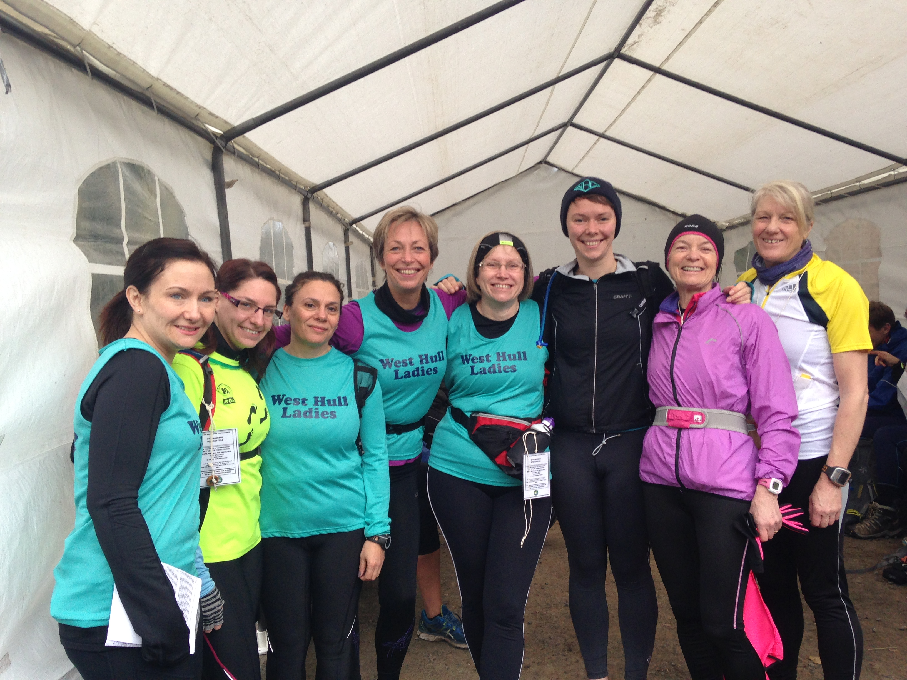

Meet a Member : Liz
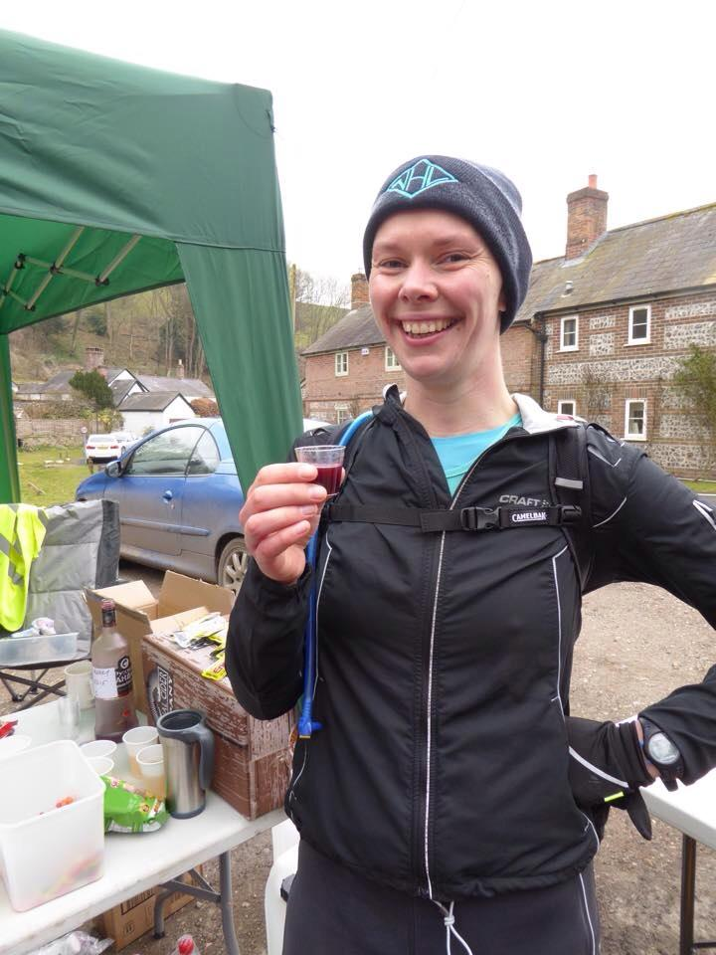
Name Liz Draper

Age 28

Member of WHL since 2014

What do you do when you’re not running? I work for City of Culture, so that’s unsurprisingly taking up more and more of my time. Outside of work, I enjoy cooking and playing with my two new kittens. And that’s it really – work, running, food and cats!

How long have you been running? About 11 years now, but it took 10 years for me to join a club because I’m a grumpy sod who enjoyed running alone and not having to talk to anyone. But fortunately for me, Linda lives round the corner from my dad, and one day she saw me out running and we got chatting. From then on, every time she saw me she would ask when I was joining WHL! Eventually I did – thanks Linda! ☺

Why did you start running? It’s a short story: mum ran a marathon and I was jealous! It took me a long time to get up to that distance, but I’m really glad I did. Running is such a big part of my life now that I can’t really imagine life without it.

Favourite distance My favourite ever race was a 37-mile ultra-marathon. It’s a long way, but I can’t think of a better way to spend a day than running around in the countryside for 8 hours. Plus you can eat whatever you want for weeks and no one can judge you!
Favourite bit of running kit Last Christmas I got some fantastic Adidas trail shoes which I LOVE. I’ve honestly never had a more comfortable (or muddy) pair of shoes.
Any injuries? I’ve been pretty lucky with injuries. I had some knee problems about five years ago, but I’ve lost a bit of weight since then and that seems to have sorted it out. Touch wood…
Running goals? A few years ago I decided I wanted to run 30 marathons before my 30th birthday… and then I told everyone about it, so I couldn’t back out! It’s been brilliant motivation, because I always have a race on the horizon, and it’s definitely made me a better runner. I’ve got nine marathons and 22 months to go, but I’m already thinking about the next challenge. 100 marathon club, maybe?!
Proudest moment running related or otherwise My proudest running moment was beating mum at the Manchester marathon earlier this year. Sorry mum! It did take me 17 tries though, so it’s probably not much to boast about.

Best piece of advice you’ve received To do strength training. It’s improved my speed and my endurance, and I’m sure it’s got something to do with the fact that I rarely get injured.

Testing, Testing 1-2-3 : Amanda

I decided to get out and do some 10K races. This was mainly for my own self-confidence as my running dipped dramatically when I hit ‘The M’. That was May 2014 and my 10Ks became about 2 mins slower. I thought I had improved over the year but the Champagne League races this year said otherwise.
Also, because of ‘The M’ I decided this year would be the time to join my husband and try cycle racing. It wasn’t a great success– best position 2nd last – but after the sheer terror of the first few races I quite enjoyed cycle racing. And, how very civilised! Cycling has a season. It finished and I decided to find out where I was with run races.
So I booked Haltemprice, Deepdale Dash and Dalby Dash. 10K is a nice distance and I was determined to get out and enjoy running competitively.

Haltemprice: This was special because so many club ladies ran it. It was good conditions for running and I felt happy just to be there. I worked hard up the hill but possibly held myself back a little as when I finished I was not as tired as usual. Was a little disappointed in going over 45 mins (45:10) but, pleased with my position of 4th out of 104 ladies. Really pleased that 3 other club ladies took prizes too.

Deepdale Dash: First time on this circuit but I had recce’d it with Sandra and Ian C and I had cycle raced on this circuit. I was looking forward to it as the hills are shorter that Haltemprice so I could give more knowing I would soon hit the flat or downhill and could recover.
The race went well and I enjoyed the circuit. However, the end of the race is harsh as there is a short uphill and at this point my legs felt sapped. The gradient flattens as you reach the field. Despite only 3 short sides but the grass was quite long and wet and it was really tough. Along the second section I could hear someone behind and a supporter shouted to him “Go on, you can take her!” Oh dear, not the best thing to say, he had no chance! I sprinted for the line finishing in 44:34. There was a stronger field at this race but 7th out of 129 ladies was a good result.

Dalby Dash: First time on this one and I had heard it is tough – 2 miles uphill to start then off-road. The weather prior to the race was awful – big downpour but it had stopped by the time the race started and remained dry. I quite enjoyed the long uphill. Just got myself to a level of discomfort and held it. The off-road was a hard surface with some lose pebbles which was fine for running, easier than expected. The downhill was longer than the uphill …. now that’s unusual! owever, it was very easy to lose concentration and to stop working hard.

Shortly after 8K we turned onto flat and sometime slightly uphill roads which now felt really tough and I just had to dig in. Very pleased to finish in 44:23 but it was a short route (probably 9.7K). I finished 8th out of 180 ladies which was great.

And did that help, oh yes it did . I am still about 90secs slower than ‘pre M’ but I am obviously doing OK and I hope to improve further – people tell me it gets better. The most important thing is to enjoy the racing and I did. I am looking forward to more.

Leeds Abbey Dash Ten K : Jill

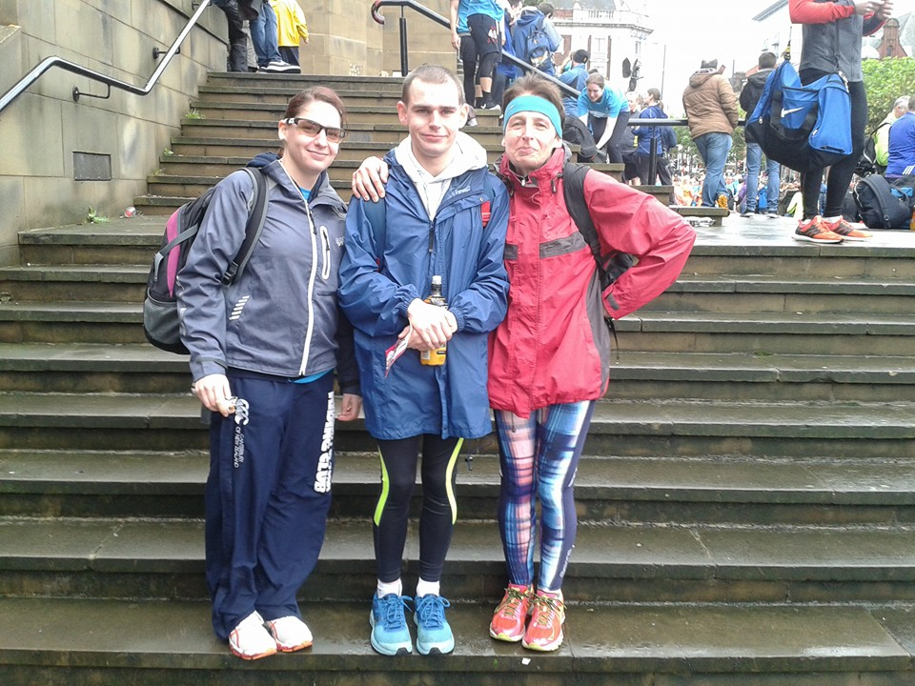

I originally entered this and thought it might be a good race for son Mike to do because the write-ups seemed to be good and I somehow had the impression that this was a small race around Kirkstall Abbey…how wrong I was…It is actually a massive race with around 11,000 people…which is a bit of a worry for me as I am always scared in these situations in case I lose ‘Speedy Mike’. Fortunately, bike friend ‘Speedy Wayne’ said he would run as a guide runner with ‘Speedy Mike’, so I was quite relieved.
Coming up to the event, there was an amber weather warning for high winds and rain in Leeds, so I was not exactly looking forward to getting up at 5.30am on the Sunday morning (ugh!). Anyway we did set off (too) early and got into Leeds just before 8am…This is now going to turn into a bit of a rant…okay so I will start off with some good things about the race. Firstly they gave Mikes guide runner a free entry, which was great as it was £22 to enter, so thanks to the organisers for that. Second, the tee shirt was quite nice, albeit a bit like ‘rent a tent’ but I’ve seen worse. Third we went into Wetherspoons and had Nutella on toast and a cup of tea before the event (although they were a bit mean with the Nutella!). Fourthly, we had a great laugh doing lots of moaning throughout the day lol!

Evil Sheriff Duathlon: Jill

Robin Hood Duathlon a.k.a. Evil Sheriff Duathlon, a.k.a. You must be absolutely barmy in your head to do this Duathlon!

I’ve done what used to be known as the ‘Evil Sheriff Duathlon’ a couple of times before and quite enjoyed it. It is a ‘run, bike, run’ off road event which used to be 5k run followed by 16k bike , finishing with t 3.5K run around Sherwood Pines in North Nottinghamshire. I decided to have a go again this year at the renamed Robin Hood Duathlon, which also sported a longer mountain bike section of 20k. Now under normal circumstances you would suggest that in effort terms, biking off road is equivalent to twice a similar distance on the road, in fact just to give you an idea, I did a flat 20k in around 38 minutes in the triathlon I did recently, whereas my off road time for this event was 1 hour 18 minutes! Setting off on Saturday morning with biking friend Wayne who was also daft enough to enter this event, I was slightly worried. I knew from having ridden some of the course the previous weekend that it was quite wet and muddy, although perfectly doable. Unfortunately, during the week it had been seriously raining, which increased my anxiety and on the morning of the race it wasn’t far off monsoon conditions! We had already got soaking wet just putting the bikes on the car at ‘stupid o’ clock in the morning, and on arriving at Sherwood, the rain was still quite relentless. After having signed on and been given my chip, numbers for me and the bike, security band and Tee shirt, I was very tempted to watch all the other nutters do the course and then go home, but no…the idiot in my inner self said, no, you have paid a vast sum of money to be miserable in rain so you better get on and ‘enjoy’ it!

After racking the bike in transition, we had a race briefing that was very ‘encouraging’. With advice to make sure you lifted your front wheel when hitting the huge pools at the bottom of the scary descents so that you don’t go over the handlebars, to reassuring us that they had at least three ambulances at various places on the course, I felt pretty worried!

9.30am came and we all started on the 5k run. This was actually quite a nice but undulating course and the going underfoot was quite good. The real fun started on the bike course however. I actually know some of the course quite well as I have ridden it a few times. I knew that the first part was quite reasonable, but that this went on to a section with some vicious hills, followed by some death defying (slight exaggeration here!) down-hill sections, with huge puddles (lakes) at the bottom followed by uphill rutted gloopy mud sections (the consistency of sticky toffee pudding!). There are at least four descents on the course that are scary in the dry, but in the wet you almost have to close your eyes and hope for the best! You also find yourself getting splattered from your own front wheel and also the person in front of you, and in such conditions wearing goggles/glasses etc is almost impossible (I’m not selling this to you am I?). You also hope that the person in front doesn’t a) fall off, b) stop, c) bottle out, d) have a bike failure, e) have a heart attack and so on, because once you stop in the mud, you almost have to be dug out! The glasses thing is also a bit of a problem for me as I am quite long sighted so can’t really see obstacles on the track…probably just as well really as it was probably best not to see what was in front of me if I’m being honest! After the hilly section, there is a nice twisty sandy downhill section that I really like. By this time I was thinking with relief that I’m nearly at the end of my first lap, however, there was then a sting in the tail. On previous years, the bike section was 16k, but they had increased it to 20k, so there was this horrible black slimy wooded section, which was twisty, rutted and had a horrible drop off coming out of the wood, with steep drop to the side, if you got it wrong! The problem with drop offs is that if you don’t take them fast enough, you can tip over the handlebars, and we weren’t going anywhere fast at that point, so I was really careful to keep my weight back. Of course, on finishing the lap, you had another one to do…and you knew by this point what was in store (gulp!). The second lap resulted in the course being even more churned up. Although it had stopped raining by this point, the mud was solidifying on my face, (and everywhere else) as the wind hit me. I can’t remember the number of times I nearly fell off, but actually I managed to get my feet down every time. I also spent lots of time on the bike talking to myself and saying some very rude words…I think that some of competitors thought that I might be suffering from Tourette’s as I kept spontaneously congratulating myself for still being upright on the bike! I was seriously relieved when I got back to transition to start my 3.5k run although I was a bit concerned that my calf muscles were threatening to cramp.

Fortunately, I was able to stave off the cramp and was able to do the run without stopping to stretch. I was quite pleased with my second run which was around 18 minutes. All in all I was, delighted that I finished and chuffed with being 2nd in my age cat (although most people my age clearly have more sense!). I also have been cleaning up sand and mud all week from the kitchen and bathroom surfaces in the house, and had to put all of my clothes in the washer including my trainers…in fact I’d have put the bike in, if it would have fitted!
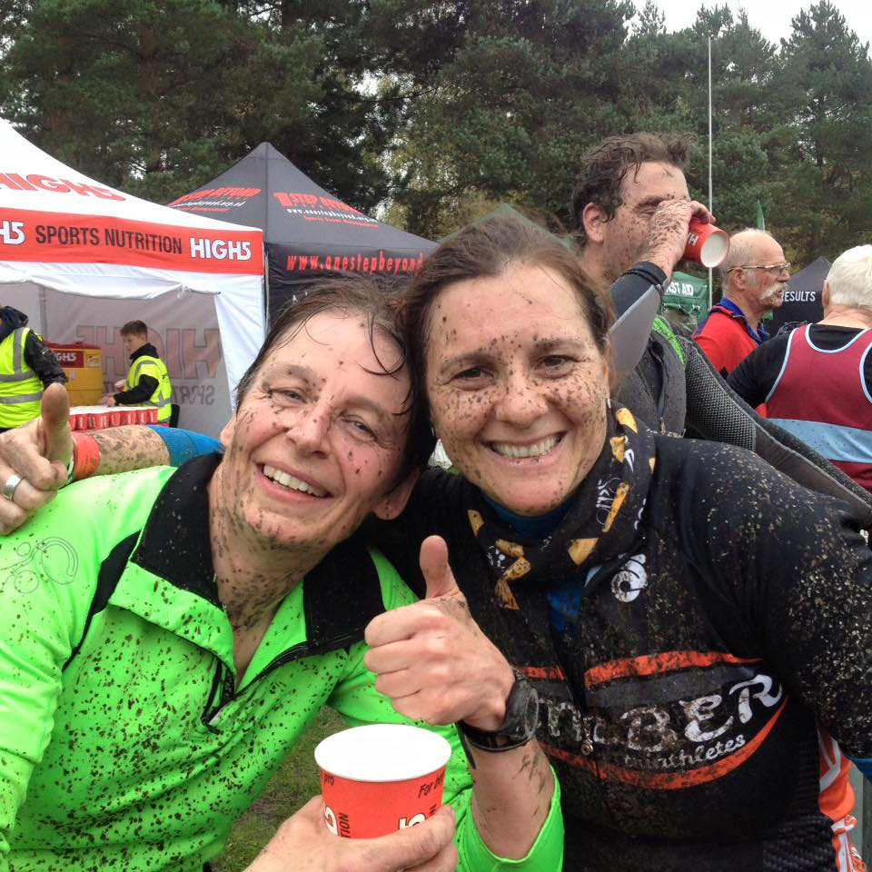

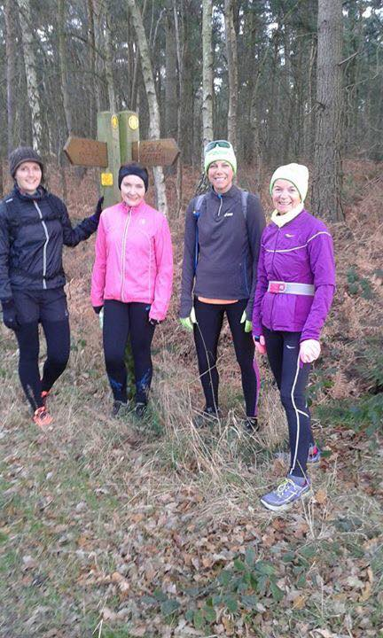

Adverts:
West Hull Ladies Christmas Events:
Christmas is on its way and we have two little events to get you in the mood!
The Christmas Lights run on Wednesday 16th December, where we head out en-masse wearing tinsel and baubles and run through Cottingham Christmas lights – about 6 miles but if you want shorter you can be collected from West Bulls making it 3.5 miles.

Advent Calendar run on Monday 21st December is a trot through the Avenues checking out the Christmas windows which people have prepared. We invite you to bring your children along, lots of stop, starts and they are usually very keen to search for the next window. The run finishes at the club where a little buffet is provided. Numbers to Maria by Sunday 13th December.

0- 5 K course in January

The beginners running course is to take place again in January 2016
We already have 3-4 ladies interested in the course. There will be a limit of 20 places. If you have friends, family or colleagues interested in taking up running in a very supportive environment, please point them to our website.
After reading about it, if still interested they should use the contact link from the page to drop us an email where their questions (and any concerns) can be answered and they can book onto the course.

Please can you advertise http://westhullladies.org.uk
Here is the link to the leaflet: Six Weeks to a 5K - Leaflet.docx
If you are able to pin it up at work/school (for 16 years and over) please do.

Fundraising News

A super evening was hosted by Fatma in November to raise funds for Refuge, the charity that she will be running the London marathon for.
A fabulous selection of cakes was enjoyed that evening, and more followed after the next the club run, making a wonderful total of £105.50
"I raised £105.50p from the event and Friday night's training session. Thank you to all that came it was a lovely evening with lots of cake and laughter."
Fatma x

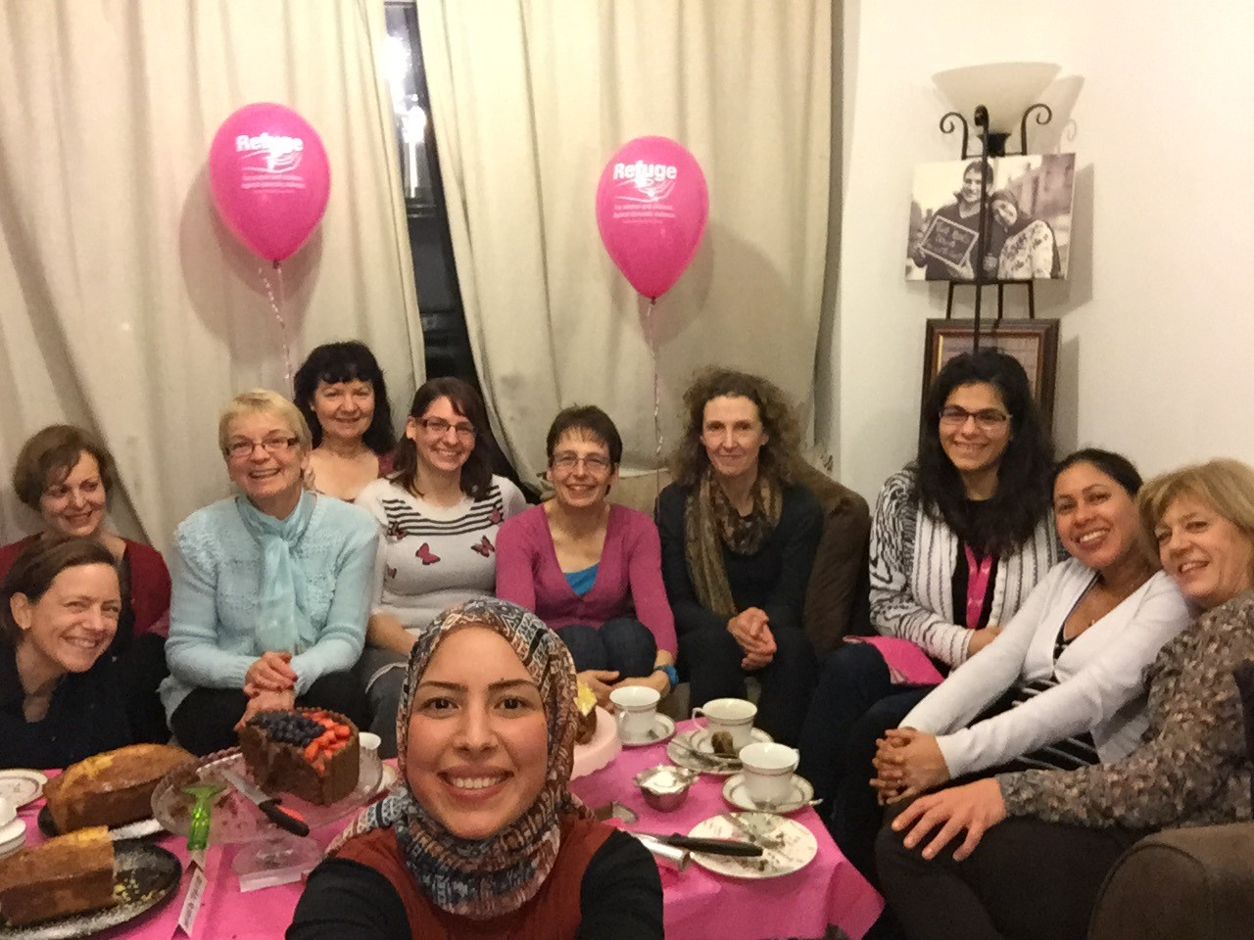

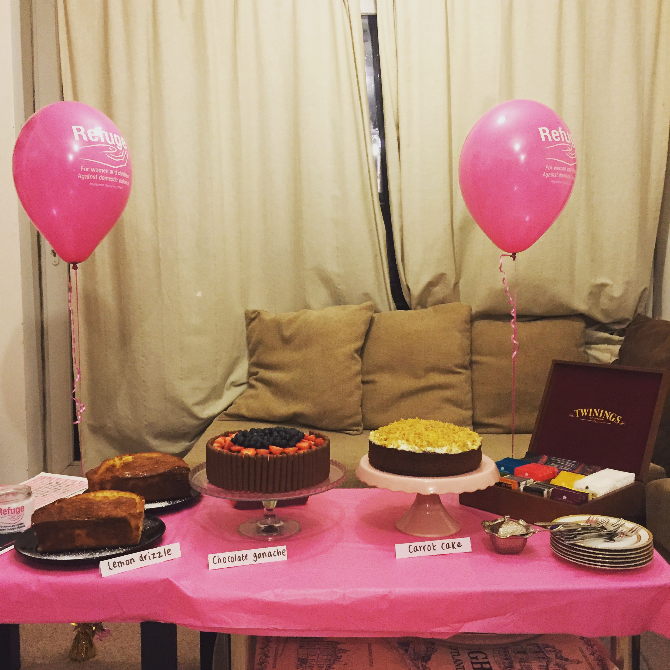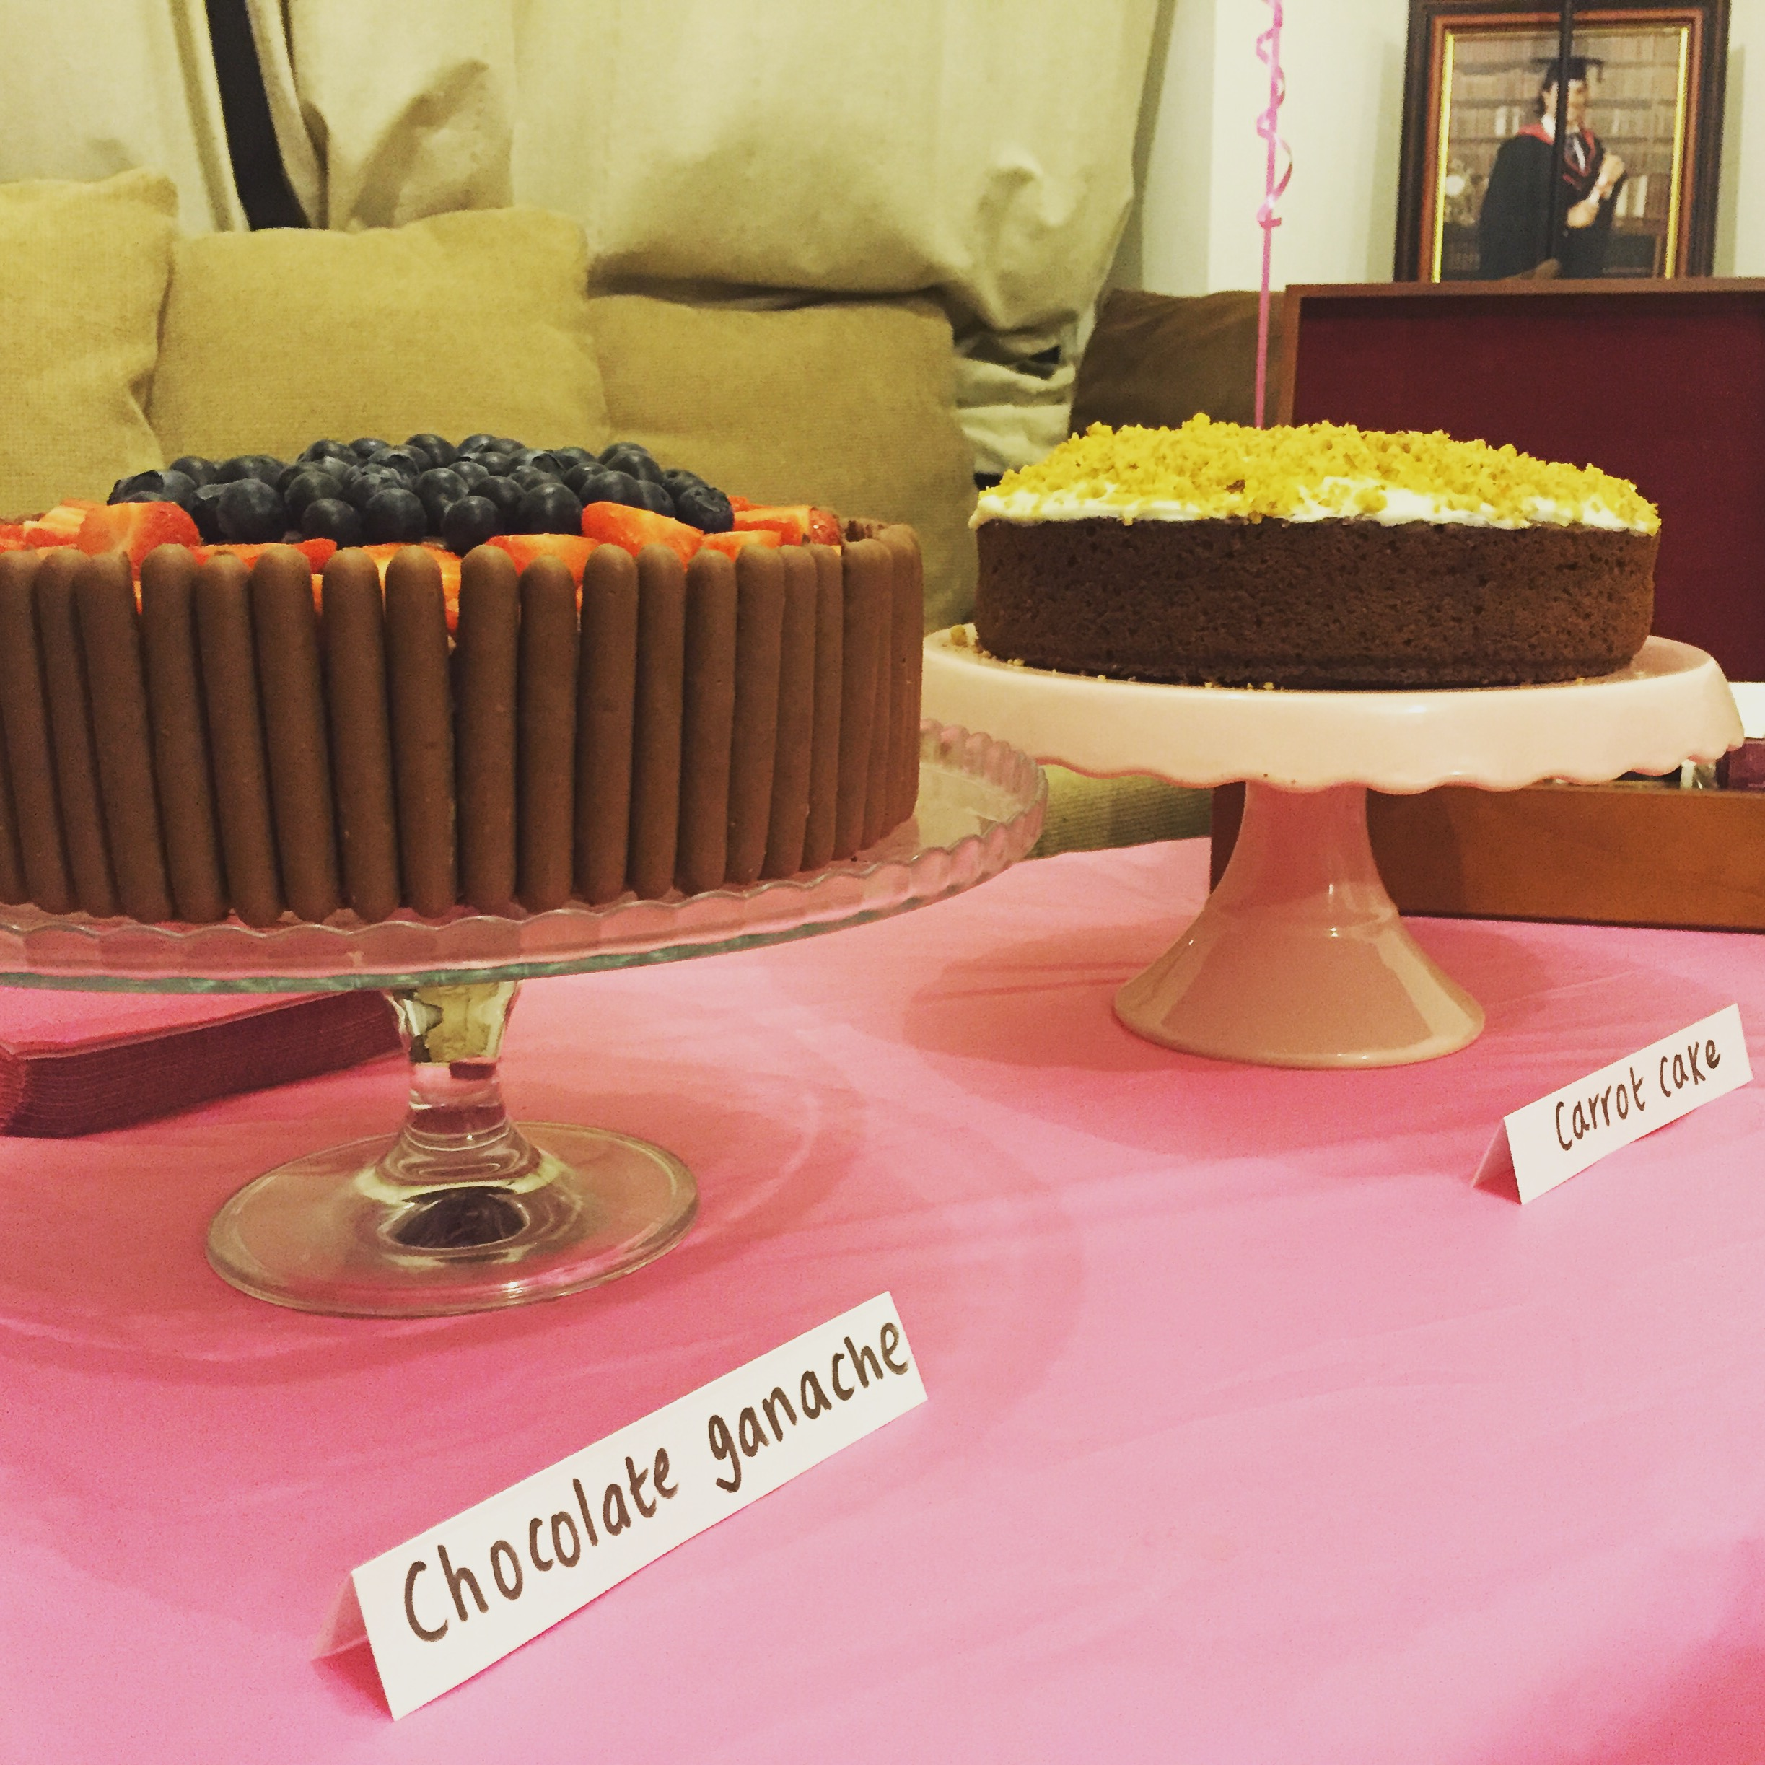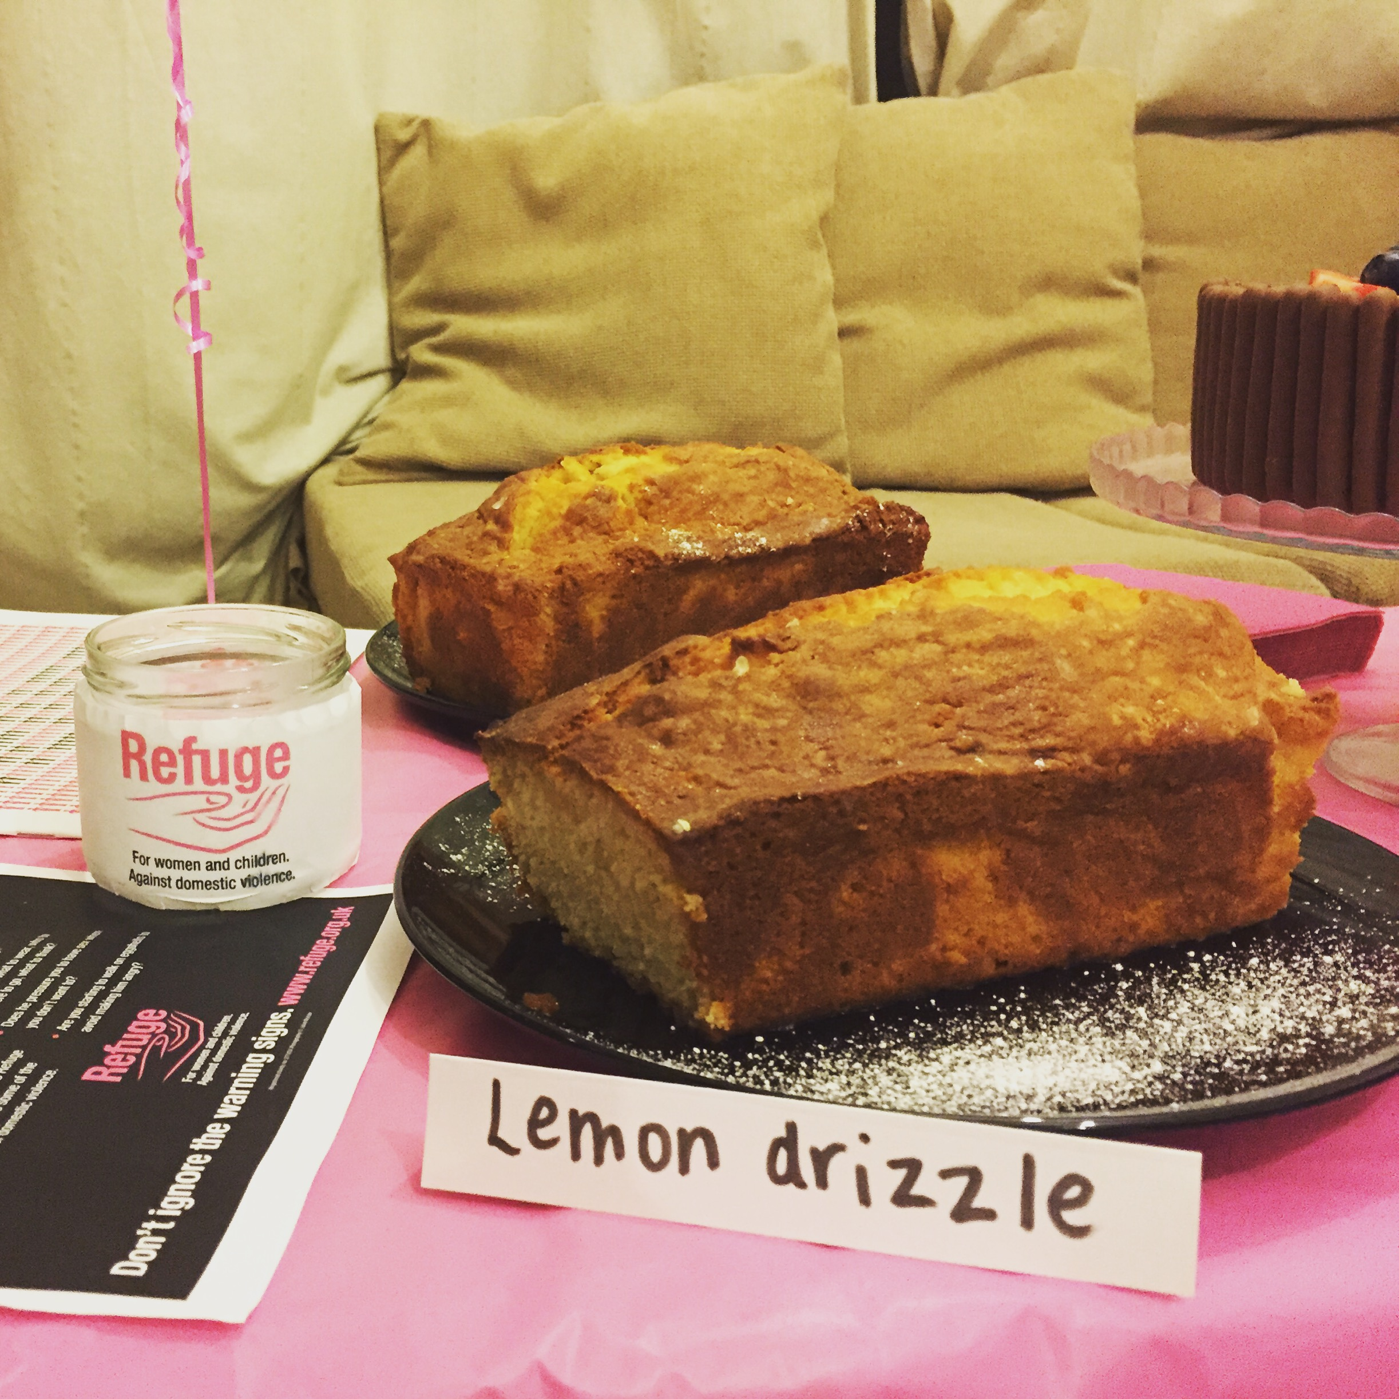

2015 RACE DIARY
http://westhullladies.org.uk/races.htm
Free 5K time trial every Saturday 9am: Hull Parkrun or Peter Pan Parkrun Humber Bridge parkrun

 | Date/Time | Event | Fee | Entry forms | Online entry
December 2015
 | 5th/08:30 | EYLDWA Rudolph's Romp | £10 | Entry form | Postal entries only
 | 26th/10:00 | East Hull Harriers Boxing Day 10K | £4 UKA/£6 | Entry form | Postal entries only
January 2016
 | 1st/10:30 | Cleethorpes New Year's Day 10K | £12 UKA/£14 | Online entries only | Online entry
 | 1st/11:00 | Beverley Lions New Year's Day Fun Run (3K, 6K and 10K) | £TBC | Entry Form | Postal entries or enter on the day
 | 17th/10:00 | Brass Monkey Half Marathon | Race Full | Race Full | Race Full
 | 24th/10:00 | Ferriby 10 Miles | £15.50 UKA/£17.50 | Online entries only | Online entry
February 2016
 | 21st/11:00 | Snake Lane 10 Mile | Race Full | Race Full | Race Full

Please remember to double check dates, times and entry fees with the official website or the entry form. Zx
Keep checking the website for new races and updates:

NOTE: Club Vests must be worn at any races you enter
under the West Hull Ladies running club name.

West Hull Ladies Road Running Club
Kit Order Form

NEW STYLE VESTS are purchased direct from www.pbteamwear.co.uk
On website: click on Clubs, Athletics Club, West Hull Ladies RC
Pick your size, name you wish to have on the front and follow payment instructions

For all other purchases use this form.

FORENAME ___________________________________
SURNAME ___________________________________

ORDER - tick what you require and circle your size Price
- OLD STYLE VEST SIZE 10 12 14 16 £10.00 (useful for training)
- LONG SLEEVED SIZE 10 12 14 16 £18.50
- HOODIE SIZE XS S M L £20
- HOODIE with ZIP SIZE XS S M L £20
Note on size: M is approximately size 14

- BEANIE HAT £6.50
- PINLESS WHL NUMBER FASTENERS (set of 4) £3.00

DATE Ordered _______________
AMOUNT PAID _______________

Please transfer payments online with your name and marked as ‘Kit to:
Account: 63762742 Sort Code: 20 43 49

Or cheque payable to ‘West Hull Ladies RRC’, and write your name and ‘Kit’ on the back and give to Club Treasurer Linda Dodsworth, 110 The Stray, South Cave, E Yorkshire. HU15 2AL

Sign on receipt of goods _________________________________
DATE _______________

Please complete this form and email to diazmaria@btinternet.com
Thanks.
Maria Kit Officer

